Department of History Graduate Handbook

Welcome to the graduate program in the Department of History at Penn State. This guide covers the major milestones and other relevant information that you need to earn your PhD in a timely manner. Of course, your longer-term goals probably include a successful academic career. The department maintains a set of graduate student resources separate from this handbook to assist in finding jobs and providing career advice beyond earning the PhD.

Contents

The Big Picture
Overview of Time to Graduation Requirements
Key Faculty and Staff
Funding
Conference Travel Funding
Summer Funding
STAP (Summer Tuition Assistance Program)
RGSO Funds
Matching Funds
Endowed Fellowships
Dissertation Release (DR)
External Funding Sources Databases
Teaching
Post-Doctoral Teaching Fellowships
Maintaining Satisfactory Standing (Doing Good Work)
New Students
Service as a Teaching or Research Assistant
Course Load and Minimum GPA
Courses in Other Departments
HIST 596
Foreign Languages and the Language Proficiency Exam
English Language Competency
Distribution of Courses
Securing and Advisor and Constituting a Committee
HIST 601
Residency at University Park
Time to Degree Expectations and Requirements
Attending Talks by Job Candidates
Service to the Department
Professionalization Seminars and Job Market Preparation
Evaluations
Academic Benchmarks
The First Academic Year (Everyone)
Semester 1 (Fall)
Semester 2 (Spring)
Summer Following the First Academic Year
The Second Academic Year (Entering with a BA/BS)
The Second Academic Year (Entering with an MA)
Summer Following the Second Academic Year and Beyond (Both BA/BS & MA Tracks)
The Third Academic Year (Entering with a BA/BS)
Comprehensive Examination Pass/Fail
Possible Committee Adjustment and Dissertation Proposal
ABD Expectations
Dissertation Defense
Dissertation Acceptance and Graduation
Support Resources
Emergencies
Counseling, Psychological Services, and Disability Services
Backing Up Work
Student Organizations

The Big Picture

As a graduate student in a PhD program, you are in the process of becoming a professional scholar. To a large degree, this process is an apprenticeship. By studying the work of other scholars, and by working directly with faculty and other graduate students, you will refine and expand your capacity as a scholar and teacher. Although earning a PhD is a major milestone, the process of scholarly development ideally never stops.

Overview of Time to Graduation and Requirements

A summary of the basic academic requirements for the PhD degree is as follows:

1. coursework in one primary and two secondary fields of history;
2. a minimum of 36 credits at the 500-600 level;
3. reading proficiency in at least one foreign language and all-around English competence;
4. at least three credits of Theory, Method and the Practice of History (HIST 500);
5. no more than nine credits (3 credits per year) of Independent Study (596);
6. formation of an academic committee to supervise examinations and the dissertation;
7. a Doctoral Qualifying Examination;
8. a comprehensive written and oral examination;
9. completion of a dissertation proposal and its acceptance by the committee;
10. completion and successful defense of a doctoral dissertation.

Everyone entering our program should have applied for the PhD program via the Graduate School. If you have entered our program with a BA or BS, you will spend three years in course work. The course load is three graduate seminars per semester (fall and spring; not summer). You may also need to take or audit one or more undergraduate courses, typically language courses, depending on circumstances. Along the way, normally at the end of the second year, you will earn a master’s degree after successful completion of the MA exam. At the end of the third year, you will take comprehensive exams. Upon successful completion of these exams, your status will become “ABD” (all but dissertation). You would typically spend the next two years completing the dissertation, for a total of five years.

If you have entered our program with an MA, you will spend two years in course work, at the end of which time you will take comprehensive exams. Upon successful completion of these exams, your status will become “ABD” (all but dissertation). You would typically spend the next two years completing your dissertation, for a total of four years.

In some cases, graduating may require more than 4 years (if entering with an MA) or 5 years (if entering with a BA or BS). However, students who require significantly longer to graduate than the time periods stated above, especially without demonstrating steady progress, will lose department funding. Moreover, Graduate School policies stipulate that if more than six years has elapsed between the passing of the comprehensive examination and the dissertation defense, the student is required to pass a second comprehensive examination a minimum of one week prior to the dissertation defense. Additionally, Graduate School policies stipulate that a Ph.D. student is required to complete the program, including acceptance of the doctoral dissertation, within eight years after the date of successful completion of the qualifying examination.

During the two or three years of coursework, summers are typically spent pursuing language training, working in archives, or other work relevant to your research. Most students will apply for academic jobs during their final year of dissertation writing.

Key Faculty and Staff

You will interact with many faculty during your time as a graduate student. The Director of Graduate Studies (DGS) administers the graduate program on behalf of and in consultation with the Head of the Department. Supporting the DGS is the Graduate Staff Coordinator (GSC). Typically, the GSC deals with the technical aspects of administration. The DGS deals with matters such as academic progress, the assignment of graduate assistant duties, academic advising, and academic job market advising. Assisting the DGS in some of these matters is the Associate Director of Graduate Studies. The Associate Director of Graduate Studies conducts new student orientation, the 602A/B seminar, and professionalization workshops throughout the academic year.

The DGS assigns a provisional faculty advisor to all incoming graduate students. In most cases, this provisional advisor will become the student’s long-term advisor and dissertation committee chair. Students should meet with their advisors regularly, at least once per semester. Consult with your advisor regarding coursework, conferences, possible outlets for publishing your work, and any other matter related to your academic career.

As a graduate assistant (GA) you will work under the supervision of a variety of faculty. The most common situation is to be assigned as a teaching assistant (TA) in a large survey course. New student orientation and the 602 seminar will help prepare you for work as a teaching assistant. Other possible graduate assistant duties include assisting faculty members with their research as a research assistant (RA), editorial support, and assisting with organizing events such as major conferences. Please note that graduate students should not undertake ad hoc work or projects for faculty members other than their TA or RA supervisors unless approved by the DGS.

Another important group of faculty with whom you will work are the professors in your seminars. Several of these faculty are likely to become members of your academic committees. It is also likely that you will rely on some of these faculty for letters of recommendation for fellowships or academic jobs. Please note that letters of recommendation tend to be more effective to the extent that they document specific accomplishments. Seminars are an opportunity to enhance your skills in analysis, research, framing key questions, academic debate, and academic writing. Excellent work in seminars will enable your professors to write strong letters on your behalf.

In addition to working with department faculty and staff, it is good practice to meet faculty in fields related to your research interests in other departments. One reason is that at least one faculty member outside of your home department is required to be on your academic committees. Students pursuing dual-title degree programs will work with faculty outside the Department of History in the course of fulfilling the dual-title academic requirements.

It is also desirable to maintain contact with the history subject-field librarian, and possibly other librarians, depending on the nature of your research projects. If there are any resources that you need for your work (e.g., database access), please ask the history subject-field librarian about accessing or acquiring those resources.

Funding

Graduate students in our program receive full funding for five years contingent on satisfactory progress. In addition to the stipend and benefits described in your offer letter, graduate students in good standing are eligible to receive support for travel to conferences and for summer research or language study. Students should also apply for supplemental funding provided by the College of the Liberal Arts, fellowships provided by entities within the university and college such as the Center for Humanities Information (CHI), and travel grants. Moreover, all students should apply for external grants and fellowships starting in the second year of their program. Securing major external fellowships enables you to focus entirely on research without any duties as a graduate assistant. External support for your research also functions as a strong endorsement of its academic viability, which is likely to be advantageous in the job market. Please note that securing external funding does not change time-to-degree expectations.

Conference Travel Funding
Presenting your research at regional, national, and international conferences is a crucial part of becoming a professional scholar. Toward the end of September, the department distributes applications for conference travel funding. Graduate students in good standing who have had a paper accepted are eligible for such funds. The department expects students presenting papers at conferences to undertake reasonable cost saving measures, explained in detail in the application, and to include an itemized budget. Moreover, conference travel applications must receive advisor endorsement and verification, and they must include an official notice of acceptance. Applicants who have satisfied these requirements normally receive funding for actual costs up to $600 for regional conferences and $1200 for major national and international conferences. The DGS, in consultation with the Head of the Department and graduate committee, determines the status of conferences and the amount of conference travel awards. Please note that the department does not fund travel to conferences that are exclusively or mainly gatherings of graduate students.

Although department does not support travel to attend conferences without presenting a paper, there is one exception to this rule. The American Historical Association (AHA) annual meeting is of such high importance for networking and professionalization that the department provides support for graduate student travel each year, funds permitting. Any student attending the AHA should participate in sponsored graduate student events, attend as many relevant panels as possible, and otherwise engage in networking with relevant scholars. Under some conditions (see the AHA web site), your advisor can register you at a discount.

There are some limitations and stipulations regarding AHA attendance support from the department:

1. The department will reimburse students for up to $500 total for the following two categories only: a) transportation and b) lodging. Conference fees, food, and other expenses are not reimbursed. However, the department will reimburse History faculty members who can register graduate students for the conference at a significantly reduced cost. You may ask a faculty member who is attending AHA to register you and the department will reimburse them for the cost.

2. It is not necessary for you to notify the department in advance that you are attending. Soon after your travel is complete, present receipts to the GSC for reimbursement. Furthermore, at the same time, submit one or two paragraphs explaining panels attended and other types of participation.

3. The length of stay must be at least two days during which the meeting is in session and panels are held.

4. You may take advantage of this support up to a maximum of three times during your time in the program.

5. AHA meeting support is separate from and unconnected with other conference travel funding.

Departmental funds to support conference travel are classified as “general funds.” Therefore, recipients are reimbursed after the travel has as occurred and been documented with receipts for major expenses such as transportation and accommodations. We strongly recommend submitting receipts for reimbursement within one week of returning from conference travel. In some circumstances, it is possible to receive some of the allotted travel funds as an advance. See the GSA for more details.

Summer Funding
Graduate students in good standing should take advantage of the summer months to pursue language training and research. There are no rigid rules, but during the first summer or two it is common in fields other than U.S. history to undertake language study. The summer is also an ideal time to become familiar with relevant archives or other resources away from campus. In January, the department distributes applications for summer funding. The DGS, in consultation with the Head of the Department, determines the amount and source(s) of summer funding.

Most summer funding comes from endowments. To receive these funds, students are required to write a letter of thanks to the donor in advance and to attend the department awards ceremony in April. Funds from endowments will be deposited into individual bursar accounts prior to the start of the summer. Saving receipts is not required for endowment-derived support, nor is any other kind of record keeping. If endowed funds are insufficient, the department might add general funds to support summer training and research. With general funds, recipients are reimbursed after their work is finished and documented with receipts for major expenses such as, program fees, transportation, and accommodations.

Important note regarding international travel: Travel to conferences or for work during the summer often requires leaving the United States. It is important to know that all international travel on behalf of or supported by Penn State must be approved in advance by Travel Safety Network (TSN). Be mindful of this requirement, and register your travel at https://tsn.psu.edu/. Also, remember that travel to Canada is international travel. International travel reimbursement is not possible without TSN registration and approval.

STAP (Summer Tuition Assistance Program)
If summer plans include coursework at Penn State, tuition is not covered as part of a graduate assistantship. Students should apply for STAP support to cover summer tuition. The basic guidelines are as follows. Although the deadline is usually at the end of June,

- Courses must be required and approved by the student's graduate program. 601 is included.
- An award cannot be delayed and transferred, e.g., from a summer session to a fall semester or spring semester.
- World Campus courses are now eligible.
- Students must go through the regular bill filing process and registration for classes in order for the funds to be directed toward the students' tuitions.
- Students will be billed for audits, which cannot be used to satisfy degree requirements, and for unapproved registrations.

For more details and a link to applications, visit this site: http://www.la.psu.edu/current-students/graduate-students/student-resources/funding-opportunities/summer-tuition-assistance-program . (If the link does not work, search “Summer Tuition Assistance Program Liberal Arts.”)

Note that applying for STAP is usually fast and easy. However, there is a limit to the total funds available. Therefore, students should apply as early as possible (typically April or early May).

RGSO Funds
After reaching the ABD stage, graduate students should consider applying for RGSO support (typically $2000 to support dissertation research or $5,000 to pay for a semester of release). [Please note that you are only eligible to apply for the RGSO semester of release the semester that you use your Humanities Dissertation Release semester or later.] For details, see: http://www.la.psu.edu/current-students/graduate-students/student-resources/funding-opportunities/rgso-dissertation-support-competition. Be sure to tell the DGS that you plan to apply, because a statement of support from your home department is part of the process. The department will add $500 in matching funds to each successful applicant (see Matching Funds below). It is also strongly recommended that you show a draft of your proposal to the DGS before the deadline for comments and editorial suggestions.

As a condition of receiving RGSO support, you must participate in the Graduate Research Exhibition the following spring semester.

RGSO dissertation support funds are deposited into individual bursar accounts, and it is not necessary to save or submit receipts for the RGSO portion of the funds. It is, however, necessary to save receipts for the amount of the matching funds from the department because this money comes from general funds.

Matching Funds
As mentioned above, the department will add $500 to the award of successful RGSO recipients. Such funds are called “matching funds” and they are general funds. Therefore, students receive the matching funds as reimbursement after the relevant travel or work is completed and receipts have been submitted. Sometimes these funds are called “top-offs,” but strictly speaking, this term refers to a different type of funding. Moreover, “matching” does not mean that the department matches the full amount of the original grant.

The department encourages students to apply for travel grants to pursue research at relevant archives or other sites and for other external grants. As an incentive, recipients of competitive external grants will receive department matching funds according to the following schedule:

Travel grants of $500-$1199 = $250 match from the department;

Larger travel grants of $1200-$2,499 = $500 match from the department (RGSO grants and other competitive Penn State grants in this range or higher are also eligible);

Competitive external grants of $2,500 or more = $750 match from the department.

Please note that to receive these matching funds, students must present information about the grant and a formal notice of their receipt of the grant. These matching funds are part of general funds. Therefore, they are distributed as a reimbursement after the relevant travel or other work is complete and the recipient provides receipts to document expenses of at least the amount of the matching funds (i.e., $250, $500, or $750).

Endowed Fellowships
There are several endowed fellowships (Hill, Knight, and Sparks), which are typically awarded to advanced graduate students for one semester. These fellowships include a stipend in roughly the amount of a graduate assistant stipend plus the same benefits. The advantage of a fellowship is that it releases the recipient to focus entirely on research and writing, with no duties as a teaching or research assistant.

Hill Dissertation Completion Fellowships enable advanced ABD students making good progress to extend their funding one semester beyond the usual expected graduation time. These fellowships typically include a formal stipulation that the fellowship semester is the final semester of funding.

In many cases, students receiving an endowed fellowship for one semester will combine that award with their Humanities Dissertation Release semester (“DR semester,” see below) to create an entire year devoted to research and writing. However, this fellowship + DR combination might not always be possible.

Humanities Dissertation Release (DR)
Whether combined with an endowed fellowship or used separately, all history graduate students receive one dissertation release (DR) semester, which can be used after attaining ABD status. As the name suggests, during the DR semester, a student receives a graduate assistant stipend and benefits but is released from all duties as a teaching or research assistant. DR students are expected to spend the release semester engaged full time in research and writing. Moreover, DR students must remain in residence unless they receive written approval from the DGS to work elsewhere. (This permission is only granted for academic reasons.)

Students should also consider applying for Penn State Centers and Institutes grants, which supplement the DR semester with extra research funds or other benefits. Applying for these grants requires submitting a proposal and timeline during the spring semester prior to the academic year in which the DR semester occurs. Note that affiliation often requires regular participation in Center events and other restrictions. Students should weigh the benefits of affiliation against the drawbacks.

Note well that students must participate in the Graduate Exhibition (spring semester) immediately after taking their DR semester. This obligation holds even if students are abroad (there is a remote participation option).

Note that the Humanities Dissertation Release goes by names such as “dissertation release,” “teaching release,” “research release” “release,” and possibly others. As a result, students sometimes think that there is more than one semester-long release from duties granted by the College to all graduate students in the humanities. There is not, and all of these terms refer to the DR semester.

The RGSO release mentioned above is competitive and separate from the DR semester.

External Funding Sources Databases
The DGS and GSC maintain databases of possible external funding sources. They are typically in the form of spreadsheets and are available to graduate students as part of a BOX folder of useful resources.

Teaching
We encourage advanced graduate students to teach one or possibly several courses as the instructor of record. Teaching should be coordinated with the DGS and with the Director of Undergraduate Studies. Note that the Director of Undergraduate Studies schedules department courses.

Teaching should not extend dissertation completion and defense. Teaching one or two sections during a summer session is common, and graduate students in this situation will receive pay at the usual instructor rate. When teaching during fall or spring semesters, the typical arrangement is to teach two sections of the same course, usually a 100-level course. This teaching substitutes for TA or GA work, so ABD instructors receive the usual pay and benefits associated with their assistantships. Note that teaching is not appropriate during DR or fellowship semesters.

Post-Doctoral Teaching Fellowships
Sometimes students who graduate in a timely manner with strong academic records fail to secure outside employment during their first year on the job market (typically the final year of dissertation writing). In such cases, the Head of the Department may authorize appointment of recent PhD recipients as post-doctoral teaching fellows for one academic year. The main purposes of the appointment are financial support for a second year on the job market and enhancing prospects for success. Post-doctoral teaching fellows develop their portfolio by teaching a variety of courses and are expected aggressively to pursue employment opportunities. Post-doctoral teaching fellowships are not renewable. (Note that in response to the COVID-19 pandemic of 2020, the department has allowed the renewal of Post-doctoral teaching fellowships. This situation is a temporary measure.)

Maintaining Satisfactory Standing
(Doing Good Work)

As fully-funded members of the department, there are duties and responsibilities that graduate students must fulfill. The paragraphs below outline the major requirements for maintaining good standing within the department.

New Students
Newly entering graduate students are required to participate in new student orientation, to complete SARI training before the start of classes, and to participate in the 602 seminar sessions. Entering students typically enroll in HIST 500 during the fall semester of their first year. Additional expectations are that students will pass the foreign language proficiency exam during their first year and that they find a suitable advisor by the end of the first year.

Service as a Teaching or Research Assistant
The default expectation of all students in our program is that they serve as teaching assistants (TA in this guide, sometimes GTA in other documents for “graduate teaching assistant”) or research assistants (RA in this guide; sometimes GRA in other documents). Typically, throughout the first two years in the program, and sometimes longer or later, students serve as TAs in large survey courses. Relatively senior graduate assistants sometimes work as RAs or editorial assistants for academic journals. All of these positions require 20 hours of work per week, on average, under the supervision of a faculty member.

The main purpose of a TA assignment is to learn from the supervising professor’s course design and execution and to support that course as required by the supervising professor. This support can take a variety of forms, including (but not limited to) leading discussion sections, grading exams or other student work, distributing materials, supervising makeup exams or quizzes, and coordinating academic accommodations. Similarly, the main purpose of an RA assignment is to learn from the supervising professor’s research program and to support that research. In either type of position, the supervising professor determines the details of the work.

A large portion of the orientation for new students is devoted to policies and best practices in connection with working as a teaching assistant. The supervising professor will meet with TAs before the start of classes and explain the specific duties of the position. Depending on the total enrollments, we usually assign two or three TAs to each large survey course. In those courses, effective teamwork between the TAs and between TAs and the supervising professor is an important component of TA performance.

Although the details of each TA assignment will vary with the course, one overarching principle is that the instructor of record for the course (i.e., the supervising professor) creates the syllabus and determines the details of course administration. While it is common for TAs to create an information sheet about themselves and their discussion sections, TAs would not normally create a syllabus for their discussion sections. In any case, TAs should obtain approval from the professor in charge of a course before distributing documents with any bearing on course work, course procedures, or course policies.

The DGS will make TA and RA assignments in August (for the fall semester) and December (for the spring semester). To make those assignments effectively, all graduate students who will be working as graduate assistants should fill out and return the relevant information form by the deadline specified by the GSC.

Students on fellowships (e.g., Hill, Knight, McCourtney, Sparks, CHI, DR, and major outside grants) that provide support comparable to a GA position are released from all ordinary duties to focus entirely on research and writing. It is a condition of these fellowships that recipients spend all of their time working on their dissertations. Therefore, teaching or other paid work is not permitted during fellowship or DR semesters.

Course Load and Minimum GPA
Students in coursework must complete three graduate seminars (9 credits) per semester and maintain a cumulative grade point average (GPA) of at least 3.5. Seminar grades of B+ or lower are cause for concern in the annual review process. Students whose GPA falls below 3.5 in any semester are automatically on probation. If the GPA does not return to 3.5 or higher at the end of the next semester of coursework, the student will be dropped from the program.

Graduate seminars are defined as courses at the 500-600 level. On rare occasions, students may take a 400-level course, augmented with additional work, to count as a 500-level course. In such a case, there must be a compelling reason, the course must receive DGS approval, and it must be taken as HIST [or a different prefix] 596 (individual study). That course will count as a student’s sole permissible annual 596. See “HIST 596” below

Courses in Other Departments
Other than courses taken to fulfill the requirements of dual-title degree programs, graduate seminars in other departments generally do not count toward the requirements of the history program. However, in some cases, a course offered outside of the history department makes sense for a student’s program. Courses taken in other departments must receive approval from the DGS. This approval should be in writing via a brief e-mail (there is no specific form). If the student seeking such approval has already fulfilled her or his history distribution requirements, then the outside course would be taken as credit hours to maintain full-time enrolment. If the student taking an outside course wants that course to fulfill history requirements, then the outside course substitutes for the student’s annual 596. See “HIST 596” below.

HIST 596
Each student may take no more than one HIST [or other prefix] 596 (3 credits) per year. HIST 596 is appropriate only in certain circumstances, and it would be unusual for a first-year student to take a 596. Typical uses for HIST 596 are: 1) when an augmented 400-level course counts for graduate credit; 2) for essential study not offered at Penn State; and 3) as a directed reading course in preparation for comprehensive exams. In all cases, 596 courses must be approved by: 1) the faculty member supervising the course and 2) the DGS. HIST 596 should never be taken as a substitute for department seminars. Moreover, group 596 courses (two or more students taking the same or similar 596) are not permitted. See the GSC for the form to apply for a 596 section. This form is not necessary in the case of a student taking a 500-level course outside of the history department (see “Courses in Other Departments” above). In that case, permission from the DGS in the form of an e-mail is sufficient.

Foreign Languages and the Language Proficiency Exam
Regardless of primary field, all students must demonstrate reading proficiency in one foreign language. This demonstration of proficiency is a Graduate School requirement, and our policy at the department level is to fulfill it as soon as possible. The Graduate School does not specify the language, but if possible, it should be a language useful for the student’s program. Typically, incoming students take the language proficiency exam in October or November of their first semester in residence. All students must demonstrate proficiency no later than their third semester in residency (not counting summers).

The language examination consists of one or two passages. The student will be given two hours to translate as much as possible of the passage(s) into correct English with the use of a paper dictionary. The student must demonstrate a clear understanding of syntactical structures and a basic knowledge of cultural references in the translated text.

If a student does not pass the language exam on the first sitting, a re-examination can be scheduled for the subsequent spring semester. Language exams may not be taken more than one time per semester.

Some students will also need reading proficiency in one or more additional foreign languages to conduct their research. The student’s advisor and committee will determine what additional language training, if any, is required. The advisor and committee may, at their discretion, require a formal proficiency examination in the required language(s).

Students with any language deficiencies should begin language preparation immediately upon entering the program. Language training might include courses at Penn State during the academic year, and/or summer language study at Penn State or elsewhere. All language requirements must be satisfied before admission to PhD candidacy.

English Language Competency
As required by the Graduate School (GCAC-605), all domestic and international students in research doctorate programs must demonstrate competency in written and spoken English. Each student’s PhD committee must assess this competency and note any fields requiring improvement in its report on the results of the Doctoral Qualifying Examination.

Prior to the scheduling of the Comprehensive Examination, each student’s committee must attest to her or his English language competency, as indicated on the Comprehensive Examination Request Form.

The major means for assessing this competency include, but are not limited to, formal written work, formal presentations, academic discussions in the context of coursework, and interviews with the committee. Note that this English language competency must be assessed independently of disciplinary knowledge, analytical thinking, or other skills.

Distribution of Courses
Students in the history PhD program must complete at least 27 credits of graduate-level work at the 500 level or above. HIST 500 is required of all students. Otherwise, the distribution is 12 credits in the student’s primary field, and 6 credits in each of two secondary fields. The department primary fields are: United States; Latin America; Early Modern Global; China; Middle East. Each of these primary fields can also function as a secondary field. Additionally, the department offers seminars in the following secondary fields: 1) environment, science, and technology; 2) gender; 3) transnational; 4) race and ethnicity; 5) modern global; and 6) colonialism and nationalism.

Refer to the Active Seminar List for detailed course descriptions and to know which courses count for which primary and secondary fields.

Securing an Advisor and Constituting a Committee
The DGS will assign a provisional advisor, who often becomes the long-term advisor, to incoming students. By the end of the first year all students should locate a suitable long-term advisor from among the history graduate faculty. In due course, this professor typically becomes the student’s dissertation supervisor. To maintain good standing in the program, students must secure an advisor and submit the Advisor Designation Form no later than the end of October during the first fall semester in residence. If circumstances warrant, it is possible to be co-advised by two members of the graduate faculty.

The next major task is forming a committee for supervision, advice, and to administer milestone examinations. There can be some confusion about committee composition, so this section explains it in detail. The first point to keep in mind is that the nature of the history program dictates one type of committee for the purpose of administering exams (MA [if applicable], qualifying, and comprehensive). By contrast, the logic of the Graduate School’s Doctoral Committee structure is best suited to students in the dissertation writing phase of their program. Therefore, we should distinguish between a department committee and a Doctoral Committee. A department committee is your committee up to and including the point of passing the Doctoral Qualifying Examination. A Doctoral Committee, is formed after passing the qualifying exam. The Doctoral Committee administers the Comprehensive Examination and the dissertation defense. The Doctoral Committee is recognized by the Graduate School, and therefore it must conform to Graduate School rules. By convention, department committees follow approximately the same structure as the Doctoral Committee.

The early stage of bringing together a committee typically occurs toward the end of the first year or early in the second year. At this early stage the committee is a departmental entity only. Within the department, students need a committee to administer the MA exam, qualifying exam, and later the comprehensive exams (if entering with a BA or BS), or the qualifying exam and comprehensive exams (if entering with an MA). In the eyes of the Graduate School, nobody is a PhD candidate until they pass the Doctoral Qualifying Examination. Therefore, it is not possible, officially, to constitute a Doctoral Committee until passing the qualifying exam. Sending the Doctoral Committee Appointment Signature Form to the Graduate School before passing the qualifying exam will result in the form being rejected.

Nevertheless, students should fill out this form and get all the required signatures during the month or so prior to the qualifying exam. The GSC will hold onto it until the qualifying exam is passed. They will then send the Doctoral Committee Appointment Signature Form to the Graduate School along with the relevant qualifying exam paperwork. Notice that, for the Graduate School, the qualifying exam is a major milestone. In our department it supplements the MA exam or the comprehensive exam and therefore tends to be regarded as a matter of secondary importance. Administratively, however, it is very important.

When it is time to complete the Doctoral Committee Appointment Signature Form be sure to distinguish between the outside field member and the outside unit member. Although in some cases the same person can fulfill both roles, the roles are distinct. “Outside field” refers to a realm of knowledge other than the student’s major field. The outside field can be construed relatively narrowly or relatively broadly. Examples include “environmental history,” “gender history,” “modern European history,” “demographic history,” and so forth. “Outside unit” refers to a formally constituted program or department other than the Department of History. The outside unit member must have his or her tenure home in a unit outside of history. If such a person also offers an outside field of knowledge, then the outside field member and the outside unit member can be the same person. Otherwise, they are separate people. The discussion in the paragraphs below assumes that the outside field member and the outside unit member are different people.

The core of a typical department committee consists of one faculty member for the primary field and one for each of the two secondary fields. In other words, in some sense, this department committee has two outside field members. This situation requires some attention in transposing or translating between the department’s committee logic and the Graduate School’s Doctoral Committee logic. Before explaining the matter in detail, here is the typical timeline regarding advisor and committee matters:
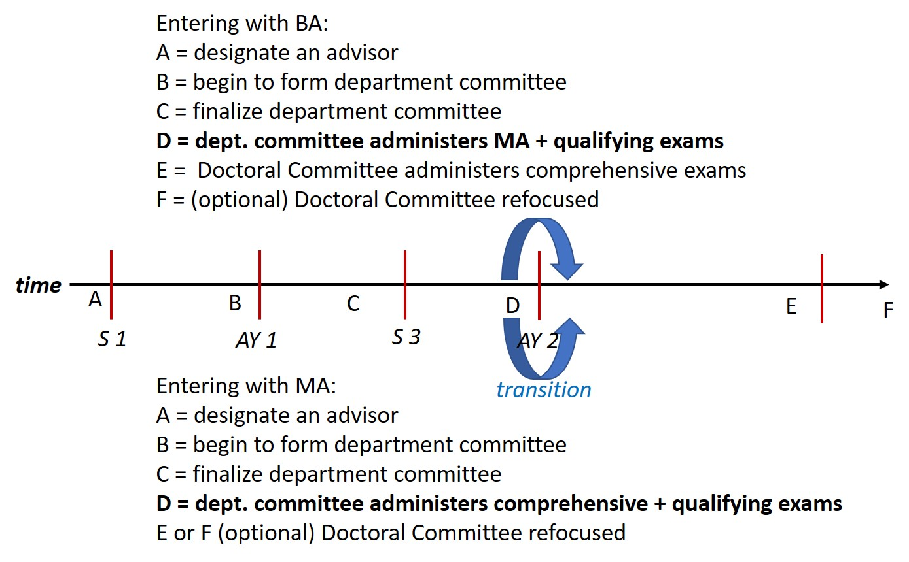

At the transition indicated by the blue arrows, it is time to set up an official Doctoral Committee that is recognized and accepted by the Graduate School. Here is the basic doctoral committee as seen by the Graduate School. It consists of four members (1-4 below):

1. A chair, who normally is also the student’s main academic advisor.

2. An additional faculty member from the student’s department who, along with the chair, represents the student’s major field. If you are co-advised within the department, then this second faculty member can be a co-chair.

3. A faculty member from the student’s department who represents a field other than the student’s major field. According to the Graduate School, the purpose of this committee member is to add a broader range of disciplinary perspective. In other words, this person’s role is intellectual breadth or diversity. This committee member is called the Outside Field Member.

4. Finally a graduate faculty member outside of the student’s department must be on the committee. This person’s main job is to represent the Graduate School and witness the proceedings to make sure that they follow the rules. This person might also play a mediating role in a conflict between the student and one or more other members of the committee. This person is the Outside Unit Member.

Notice that the official Doctoral Committee does not fit perfectly with the department-level configuration of our program prior to the dissertation stage. An explanation of those differences and how to resolve them will follow, in blue typeface.

Part of the committee-related confusion that sometimes occurs is the result of the tendency in our department, and other departments in our college, to seek outside unit members who will play an intellectual role in the student’s committee to one degree or another. This idea is fine, but notice that as far as the Graduate School is concerned, the faculty member need only be from an outside unit. This person need not play a major intellectual role in the process.

The committee composition described above might suggest that two of the history department members on your exam committee come from your primary field within the department and one of them comes from one of your secondary fields within the department. However, remember that the committee you initially constitute to administer your exams within the department is not the same administrative entity as your Doctoral Committee as recognized by the Graduate School. Usually, the personnel are the same, and this is where some confusion can creep into the transition.

Here is how to harmonize the two somewhat different worldviews. Constitute a committee to administer your exams. That committee normally consists of a chair (C) to cover your major field within our program and two other members of the department, one from each of your secondary fields (S1 & S2). Then, anticipating the future creation of your Doctoral Committee, you also secure an outside unit member, that is someone from a department other than history (OU). Approximately a month before your qualifying exam, you should prepare the Doctoral Committee Appointment Signature Form. This form will be sent to the Graduate School along with your qualifying exam paperwork. In other words, on the form you set up your Doctoral Committee. For this purpose, the chair remains the chair (C), the secondary field member closer to your primary field is designated as a second faculty member in your major field (M), and the other one is designated as the “outside field member” (OF). Finally, you carry over the outside unit member. Here is a diagram of the process:
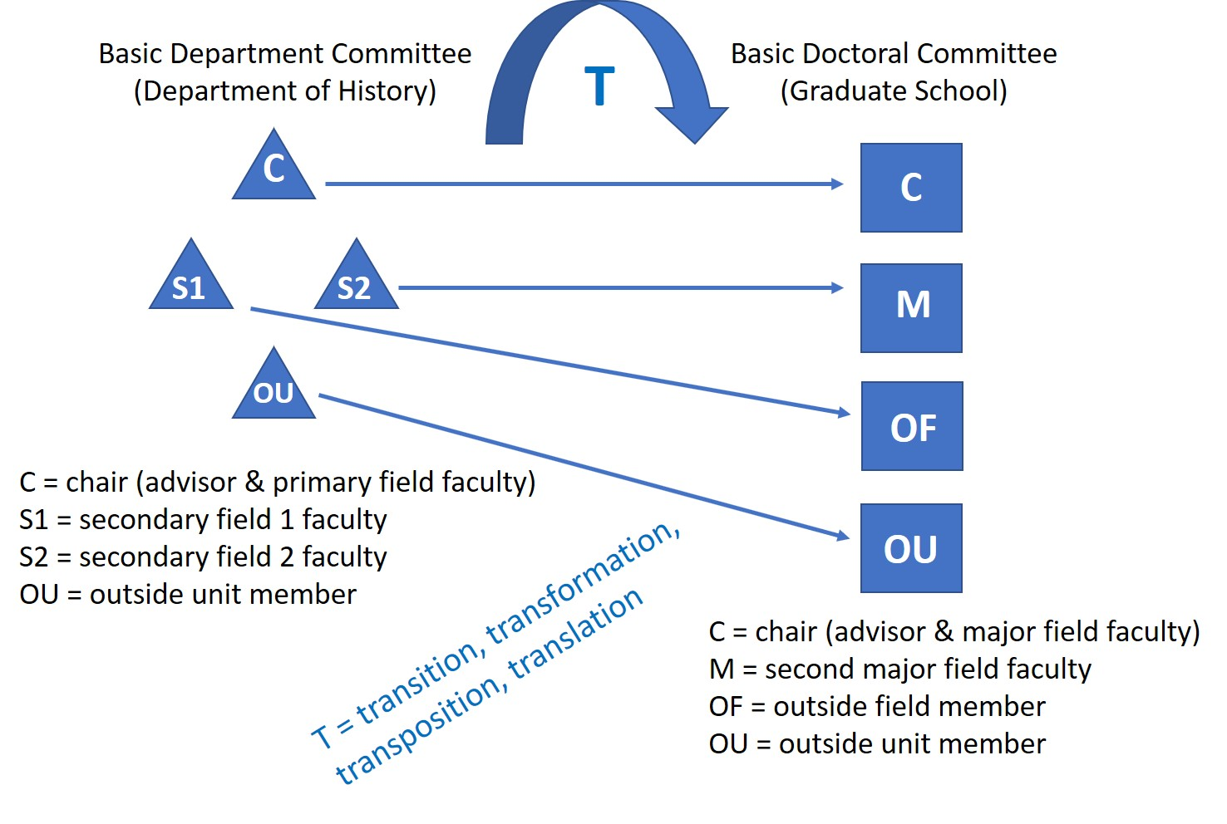

Note that on the committee form, it is necessary to specify the outside field. It can be any field of knowledge the faculty member is qualified to supervise and which is different from the major field.

As your dissertation project becomes more focused, you might want to alter the composition of your committee to include two history faculty in your primary field of specialization and one from your most important secondary field. In other words, you might want to focus or re-fashion your committee in precisely the manner fitting the vision of the Graduate School. This refocusing is not required, but the department encourages you to do so in consultation with your advisor if altering your committee makes good sense academically. In that case, you submit a new Doctoral Committee Appointment Signature Form, which supersedes any previous forms.

Faculty in the College of the Liberal Arts often hold appointments in more than one department. In such cases, one department is the person’s “tenure home” or main department. For example, someone might be 100%, 75%, or 51% appointed in History. In the latter two cases, the faculty member will typically be appointed 25% and 49%, respectively, in another department. With respect to the basic Doctoral Committee’s legality in the eyes of the Graduate School, must the outside unit member be 100% outside of History? In spirit, yes, but on the ground, things are more complex. Generally, the Graduate School does not know the appointment percentages of a faculty member with lines in more than one department. If all the administrative systems are accurate, then a faculty member who is, for example, 75% in Asian Studies and 25% in History will show up as “Asian Studies” in the Graduate School’s list of unit affiliations. It is recommended that for maximum administrative smoothness, students find outside unit members who are entirely outside of History. If doing so is difficult, however, most likely someone with only a minority appointment in History will work.

Many History graduate students are in dual-title programs. The same basic rules and ideas described above apply in this case. In the eyes of the Graduate School, a dual-title Doctoral Committee will usually consist of 4 members, one of whom takes on 2 roles. Here is that idealized Graduate School vision committee:

1. A chair from the student’s home department, who normally is also the student’s main academic advisor (C).

2A. The dual-title representative, who is the co-chair (CC).

3. An additional faculty member from the student’s department who, along with the chair, represents the student’s major field.

2B. A faculty member who represents a field other than the student’s major field. The purpose of this committee member is to add a broader range of disciplinary perspective. In other words, this person’s role is intellectual breadth or diversity. This committee member is called the Outside Field Member. Here is the good news: The dual-tile program representative can function as both the co-chair and the Outside Field Member.

4. Finally a graduate faculty member outside of the student’s department and outside of the dual-title department or program must be on the committee. This person’s main job is to represent the Graduate School and witness the proceedings to make sure that they follow the rules. This person might also play a mediating role in a conflict between the student and one or more other members of the committee. This person is the Outside Unit Member.

In this case, the Outside Unit Member must be outside of both History and outside of the dual-title program (WGSS, Asian Studies, etc.). Ideally, that person is totally outside of both units. However, for the reasons explained above, someone with a minority appointment in History or the dual-title program will probably be acceptable.

Harmonizing this committee with the exam phase in History (and the dual title programs) will most likely require that the committee initially consist of 5 people for exam purposes. Members 1 and 2 above remain the same (C = C and DT = CC). Member 3 above is a history faculty member in one of the secondary fields (S1). Next is one more secondary field faculty member from history (S2). With the outside unit member (OU), the total is 5 members. Note, however, that five members are not required for a Doctoral Committee. Therefore, when focusing the committee in the dissertation phase, reducing it to 4 members often makes sense both academically and logistically. Moreover, if the dual-title representative has a minority appointment in history and is willing to cover both the dual title material and one secondary history field, then even for exam purposes a dual-title committee might consist of only four members. What follows is a diagram comparing a typical five person department dual-title committee with a four person dual title Doctoral Committee (which is allowed to have more than four members):

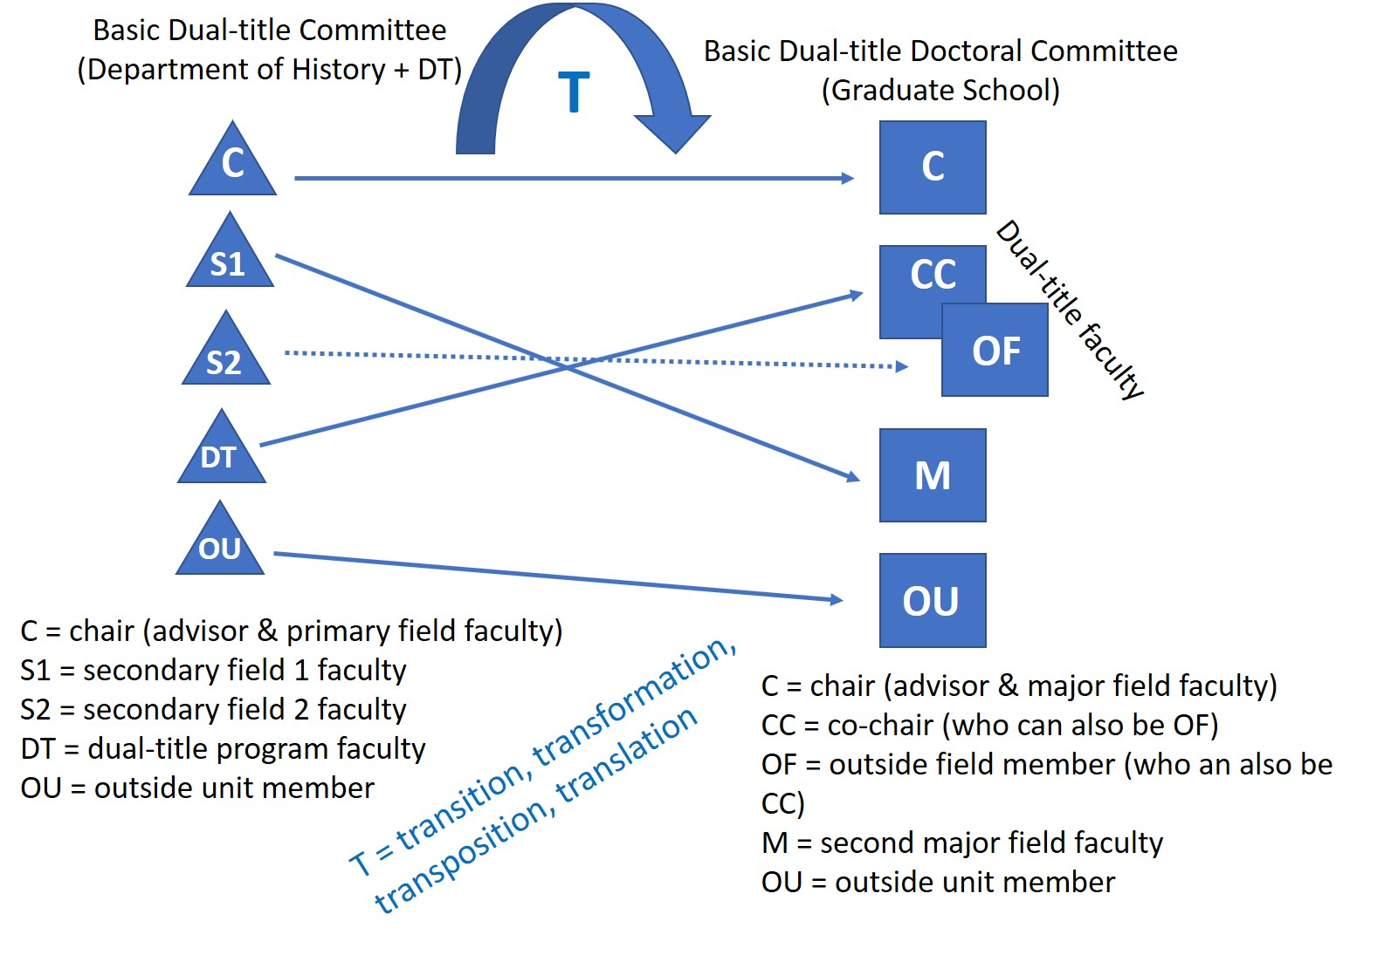

Appointing faculty from outside Penn State to graduate committees is possible, but only in the unlikely case of Penn State faculty being insufficient to supervise a student’s program. Therefore, except in extraordinary circumstances, students should select committee members from within the graduate faculty at Penn State. Nevertheless, it is desirable for students to cultivate good relations with one or more faculty outside of Penn State in the main field.

Students must constitute a viable committee no later than the end of their second year in the program. The inability to secure an advisor or constitute a committee are indications of a poor fit between student and program and will require a student to leave the program.

HIST 601
After passing comprehensive exams, students must enroll in HIST 601. HIST 601 is an administrative requirement indicating active dissertation research and writing. During the ABD phase of the program, that is, during the time enrolled in HIST 601, all students are expected to make steady and timely progress in completing the doctoral dissertation.

Residency at University Park
Upon becoming ABD, graduate students who continue to be supported by an assistantship are expected to remain in residence. Exceptions can be made for compelling academic reasons if the student's support is in the form of a research assistantship and with approval from both the supervising professor and the DGS. Note that the rules connected with the DR semester require remaining in residence unless the DGS permits residing elsewhere for compelling academic reasons. Note also that center affiliation in connection with the DR semester always require being in residence, and exceptions are not possible. Please consider this requirement when deciding whether to pursue the center affiliation option. Finally, ABD students supported by internal or external fellowships will typically reside in the place or places in which they will conduct their research

Time to Degree Expectations and Requirements
Continuation of support in the program is contingent on a reasonable expectation that a student will meet degree requirements in a timely manner. The normal time to degree is four years if entering with an MA and five years if entering with a BA or BS. It is possible that students pursuing complex research agendas may require one or two additional semesters to graduate. To receive additional support, students must provide tangible evidence of progress toward completion of the dissertation.

Except for extraordinary circumstances, the department will not provide support beyond the fifth year for students entering with an MA or the sixth year for students entering with a BA or BS. Winning internal or external fellowships and grants does not change time to degree requirements.

Attending Talks by Job Candidates
The formal presentation of current and near-future research to a critical audience (“job talks”) is a crucial component of most on-campus academic job interviews, and it is a difficult skill to acquire. Therefore, all graduate students in residence are required to attend all job talks unless the talk overlaps with a student’s seminar or other essential activity. This requirement applies to History department job talks, not to candidates for positions in other departments whose talk takes place in the Weaver building. The GSC will notify everyone of these required talks at least several days in advance. Three unexcused absences from required talks will make a student ineligible for department matching funds.

Service to the Department
There is no service requirement in the History program for graduate students. Attending job talks, as noted above, is partly a type of service, but it is also an important part of academic training. On campus and within the department, there are many talks, workshops, and other activities, and we invite graduate students to participate in them to an appropriate degree. Such participation, however, is voluntary. Moreover, we recommend against excessive participation in extracurricular activities. These activities should not take up time and energy better used for pursuing academic work. Note also that inviting speakers to campus and organizing events is a significant expenditure of time and energy. Again, we recommend keeping such activities to a minimum. There will be plenty of opportunities for organizing events after graduating.

Each spring we invite current graduate students in residence to participate in recruitment activities such as having meals with visiting prospective students or attending receptions for them. These activities are entirely voluntary. Typically, many students do volunteer, which the department appreciates, but there is no obligation to do so.

Professionalization Seminars and Job Market Preparation
The Associate Director of Graduate Studies will arrange a series of professionalization seminars each year to provide practical advice on important topics such as preparing CVs, writing effectively, and seeking outside funding. All students in residence should attend these seminars, and the Associate Director of Graduate Studies will schedule them at optimal times.

ABD students nearing completion of their dissertations should coordinate with their advisor and the DGS regarding entering the job market. The general idea is to enter the fall job market at the point when the dissertation will be complete no later than the end of the subsequent spring semester. The DGS or the Associate Director of Graduate Studies will organize individual and, if appropriate, group meetings to hone application materials. The DGS or the Associate Director of Graduate Studies will also arrange mock interviews and other interview preparation assistance when relevant. Advanced students on the job market should keep the DGS appraised of the status of their search to allow for maximum assistance from the department.

Evaluations
The work that you do as graduate students is frequently evaluated by seminar professors, supervising professors, advisors and committee members, and the DGS. At the end of the fall semester, the DGS will examine seminar grades (if applicable) and other relevant indications of progress. For students making satisfactory progress, there will be no formal notification. If there is any deficiency, the DGS will meet with the student early in the spring semester and send a memorandum explaining the deficiency or deficiencies. This memorandum will also indicate what is required to remedy the situation, and it will include a specific evaluation of either “concern” or “unsatisfactory.” An unsatisfactory rating is a very serious matter. Any student whose performance is rated unsatisfactory two semesters in a row will be dropped from the program. Similarly, a student who receives two or more nonsequential unsatisfactory ratings may be dropped from the program.

At the end of each academic year, there is a formal review process. At a minimum, this process includes a written self-evaluation, a written evaluation from each student’s academic advisor in consultation with the student’s committee, and a written evaluation by the DGS.

The formal annual evaluation from the DGS will indicate an overall rating of satisfactory, concern, or unsatisfactory. In the case of an unsatisfactory rating in the annual evaluation, if the student received a notice of unsatisfactory performance the previous semester, then s/he will be dropped from the program. If it is the first unsatisfactory rating, then the student will receive a formal follow-up evaluation the next semester.

In addition to this regular evaluation process, problems in academic performance, GA performance, or elsewhere may require formal intervention in the midst of a semester, initially by the DGS. Depending on the severity of the situation, a formal meeting with the Head of the Department may also be required. In either case, the DGS will follow up with a memorandum stating the problem and what must be done to correct it. If this memorandum states that the student’s current situation is “unsatisfactory,” then immediate improvement is essential. If at the end of that semester, or at the end of that academic year, the student receives a second unsatisfactory rating, s/he may be dropped from the program.

Academic Benchmarks

Satisfactory progress in our program involves meeting required benchmarks. The benchmarks are the same for all first-year students. The timing of the remaining benchmarks diverges from the second year onward, depending on whether a student has entered the program with a BA/BS or an MA. Moreover, (obviously) the MA exam is not applicable to those who have entered the program with an MA in hand. The chart below summarizes the major benchmarks:

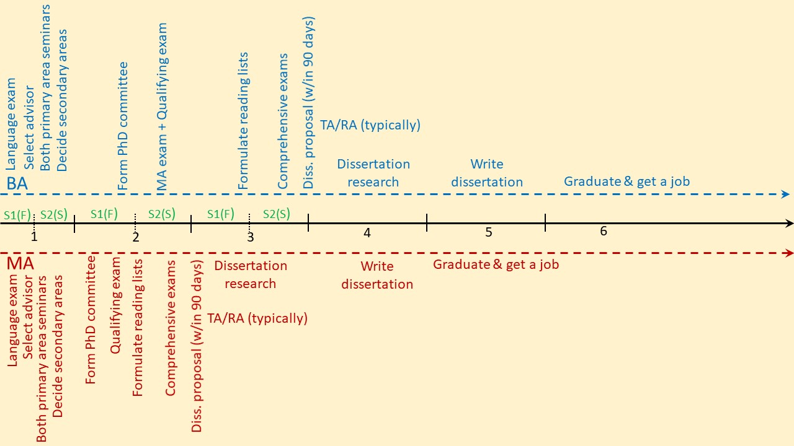

The First Academic Year (Everyone)
Coursework during the first year should include both seminars in the primary field. Moreover, students should select two secondary fields and take relevant seminars. Additionally, there are specific tasks to complete during each semester.

Semester 1 (usually Fall)

An essential task during the first semester is to find an advisor. Often the provisional advisor assigned prior to arrival will become a student’s formal advisor, but not always. Under certain circumstances it is permissible to be co-advised by two graduate faculty members in history. Students in a dual-title degree program should select a co-advisor from the dual-title degree partner. By the end of October of the first year, each student is required to submit a complete, signed copy of the Advisor Designation Form to the GSC. This form includes a space for the advisor to indicate the appropriate language for the foreign language proficiency examination. Advancement in the program is not possible without a formal advisor.

In October or November, all incoming students take a foreign language proficiency examination. It consists of a text such as an article or book chapter. The examinee has two hours to translate as much of it as possible into English. Other than a paper dictionary, no other aids are allowed during the exam. In most cases, a language instructor outside of the department grades the exam and sends the DGS a report. Anyone who does not pass the exam should take it again toward the end of the spring semester of the first year.

Students who anticipate presenting their work at regional, national, or international academic conferences should apply for conference travel support during the fall semester. Similarly, during the spring semester, students should apply for summer research funds. In each case, the DGS will send a notice with the application form attached.

Semester 2 (usually Spring)

By the end of the first academic year in the program, students should have decided their secondary fields of study and have identified two history graduate faculty members, who along with the advisor, will form a committee to advise the student and administer department exams. Eventually, these faculty will constitute the core of a student’s Doctoral Committee. Normally, the two committee members who join the advisor have expertise in the secondary fields. There is no form to file at this point, but students should meet informally with prospective committee members.

Keep in mind that a complete Doctoral Committee must also include one person outside of the department, the outside unit member. (See “Securing and Advisor and Constituting a Committee” above.) It is a good idea to locate a faculty member willing to fulfill this role relatively early. The History members of a student’s committee should be able to suggest possible faculty to serve as outside unit members. The dual-title programs may have their own requirements regarding committee composition, so students in such programs should meet with the program’s DGS no later than the second semester to be certain about committee composition and other requirements.

Each April the DGS will send a Self-evaluation Form to each student in the program. This document should be filled out with care. Before the deadline, students should send a completed copy to the GSC and to their advisors. Advisors will refer to this form as they write their annual evaluations.

In May, the DGS will send formal annual evaluation letters to all students in the program. Students should send a short message to the DGS indicating receipt of this letter. For more details, see the section “Annual Evaluations” above.

Summer Following the First Academic Year

Effective use of the summer months is crucial for making good progress. Students who need to acquire one or more foreign languages for their future research should undertake intensive language study during the first summer or two. Students not requiring language training should spend the summer investigating archives, libraries, and collections relevant to future research. Department or endowment funding is available to support research activities that the department regards as feasible and potentially productive. Moreover, students should apply for library and other short-term travel grants relevant to their work.

If summer plans include coursework at Penn State, tuition is not covered as part of a graduate assistantship. Timely completion of a STAP application should cover your tuition bill in such cases. See the subsection “STAP” in the section on funding above for more details.

Students should also consider beginning work on their Qualifying Exam essay, in consultation with their advisor and committee.

The Second Academic Year (Entering with a BA or BS)

During the second year the tracks for those entering with a BA/BS and those entering with an MA diverge in significant ways. Hereafter in this handbook, material specific to students entering with a BA/BS will appear in blue typeface. Material specific to those entering with an MA will appear in maroon typeface.

Those entering the program with a BA or BS should take all seminars offered in their primary fields and continue with seminars in secondary fields. Early in the first semester of the second year, all students should constitute their departmental committee, which will later become their Doctoral Committee. This process also requires determining the two secondary fields. In addition to a chair (the student’s advisor) and two history graduate faculty, a full committee must also include one person outside of the department.

Students should arrange their committee in consultation with their advisor. This committee will administer the Doctoral Qualifying Examination and the MA Oral Examination. History requires that students take their Qualifying Examination no later than the eighth week of the third semester. In cases where this timing precludes the inclusion of the dual-title area, the dual-title program may choose to examine proficiency in the dual-title area at a later time, but no later than the end of the fourth semester of entry into the major doctoral program.

Only after passing the qualifying examination is a student considered a doctoral candidate by the Graduate School. Therefore, prior to passing the qualifying examination, a student’s committee is a department entity only. After passing the qualifying examination, and submitting the required forms, the committee becomes a formal Doctoral Committee recognized by the Graduate School. It is the student’s responsibility to schedule the Qualifying Examination. Once committee members have agreed on a common time, notify the GSC so that they can obtain a room and send a formal memorandum to the committee members.

The Doctoral Qualifying Examination is a meeting required by the Graduate School for every student seeking a doctoral degree at Penn State. From the perspective of the Graduate School, a student “has no official status as a doctoral student and no assurance of acceptance as a doctoral candidate until the qualifying examination has been passed.” In practice, however, the qualifying exam is less an examination than the student’s first formal meeting as a doctoral student with her or his full doctoral committee.

As part of the Doctoral Qualifying Examination, it is customary for the qualifying exam essay to include: 1) a cogent overview of the student’s past coursework and how such coursework meets departmental requirements, 2) self-assessment of progress including awards, research and strategies for future external fellowships, 3) a brief description of the proposed dissertation topic. The entire essay should no more than ten pages double spaced. This essay is due to the GSC for distribution to the committee no later than two weeks prior to their Qualifying Examination meeting. The GSC will then share it with the entire committee and confirm the time, room and participation of all committee members.

During the Qualifying Exam, students will make a brief presentation of the contents of their Qualifying Exam Essay, after which committee members may ask questions. The student may also ask the committee questions. A successful Qualifying Exam should give both the student and the committee a strong sense of the student’s path forward. In evaluating the student’s performance in the Qualifying Exam, the committee will assess whether the student has made adequate progress toward the following 1) increasing their knowledge of current and past historiographical theory and methods; 2) evaluating primary and secondary source material consistent with the ethical standards and practices of the historical discipline; 3) being able to formulate and execute independent research; 4) articulating arguments and ideas with clarity in oral presentations and written formats; 5) creating historical arguments that demonstrate knowledge of professional standards. [These criteria are based on the Program Learning Objectives]

After the meeting, the committee chair will submit three forms to the GSC: the Report on Doctoral Qualifying Examination Form, the Graduate Student Committee Policies and Procedures and Committee Appointment Signature Form, and the Doctoral Qualifying Examination Rubric Form.

Please note: A student may take the Qualifying Exam only once. Those who fail the Qualifying Exam will not be allowed to continue in the Ph.D. program in History. Students who fail the Qualifying Examination will be supported through the end of their fourth semester if they choose to complete an M.A. degree. If the student chooses not to complete the M.A., she/he/they will be dismissed from the program at the end of the semester in which they took the Qualifying Exam.

During the second year, students entering with a BA or BS are encouraged to complete an M.A. degree, including an M.A. exam. The student should make this decision in close consultation with his/her/their advisor and committee members. Those who choose to complete the M.A. should ideally do so in their third or fourth semester in the program (during their second year) but may do so later. If taking the exam in the spring semester, a student may take the MA exam after spring break with DGS permission, but they should take place as soon as possible. Exams scheduled for late March or later might be too late for the student to receive the MA degree that semester. Such a situation is not a problem with respect to progress in the history graduate program, but it might be an inconvenience for the student.

To complete an M.A. degree, students will work in conjunction with their advisor and committee to determine an appropriate Master’s-worthy product. This might include (but is not limited to) an article-length, publishable-quality piece of scholarship, a collection of shorter essays (which could be public-facing in nature), a curated museum or library exhibit, a podcast, a documentary, or any other product that demonstrates the student’s ability to evaluate primary and secondary sources, create historical arguments, and adhere to professional standards of scholarly work. Students may adapt or enhance a seminar assignment for this project, but they may also choose a project of their own design. Attainment of a Master’s degree must include an M.A. Exam where the committee meets to discuss the final product.

It is the student’s responsibility to schedule the MA exam. Once committee members have agreed on a common time, notify the GSC so that they can obtain a room and send a formal memorandum to the committee members. Submit the MA product to your committee and to the DGS (via the GSC) at least two weeks prior to the scheduled MA oral exam. The chair of the committee is responsible for submitting the form Report on Master’s Oral Examination (including the Rubric for Evaluating MA Examination) to the GSC.

The Second Academic Year (Entering with an MA)

Those entering the program with an MA should continue coursework during the second year, taking seminars in the primary and secondary fields. Early in the first semester of the second year, all students should constitute a department committee, which will later become their Doctoral Committee. This process also requires determining the two secondary fields. In addition to a chair (the student’s advisor) and two history graduate faculty, the full committee must also include one person outside of the department.

Students should arrange the committee in consultation with the advisor. During the second year, the committee will administer the student’s Doctoral Qualifying Examination and the Comprehensive Examinations.

History requires that students take their Qualifying Examination no later than the eighth week of the third semester. However, a student who enters the program with an MA may, in consultation with their advisor, choose to schedule the Qualifying Exam in the second semester or in the first eight weeks of the third semester. In cases where this timing precludes the inclusion of the dual-title area, the dual-title program may choose to examine proficiency in the dual-title area at a later time, but no later than the end of the fourth semester of entry into the major doctoral program.

Only after passing the qualifying examination is a student considered a doctoral candidate by the Graduate School. Therefore, prior to passing the qualifying examination, a student’s committee is a department entity only. After passing the qualifying examination, and submitting the required forms, the committee becomes a formal Doctoral Committee recognized by the Graduate School. It is the student’s responsibility to schedule the Qualifying Examination. Once committee members have agreed on a common time, notify the GSC so that they can obtain a room and send a formal memorandum to the committee members.

The Doctoral Qualifying Examination is a meeting required by the Graduate School for every student seeking a doctoral degree at Penn State. From the perspective of the Graduate School, a student “has no official status as a doctoral student and no assurance of acceptance as a doctoral candidate until the qualifying examination has been passed.” In practice, however, the qualifying exam is less an examination than the student’s first formal meeting as a doctoral student with her or his full doctoral committee.

As part of the Doctoral Qualifying Examination, it is customary for the qualifying exam essay to include: 1) a cogent overview of the student’s past coursework and how such coursework meets departmental requirements, 2) self-assessment of progress including awards, research and strategies for future external fellowships, 3) a brief description of the proposed dissertation topic. The entire essay should no more than ten pages double spaced. This essay is due to the GSC for distribution to the committee no later than two weeks prior to their Qualifying Examination meeting. The GSC will then share it with the entire committee and confirm the time, room and participation of all committee members.

During the Qualifying Exam, students will make a brief presentation of the contents of their Qualifying Exam Essay, after which committee members may ask questions. The student may also ask the committee questions. A successful Qualifying Exam should give both the student and the committee a strong sense of the student’s path forward. In evaluating the student’s performance in the Qualifying Exam, the committee will assess whether the student has made adequate progress toward the following 1) increasing their knowledge of current and past historiographical theory and methods; 2) evaluating primary and secondary source material consistent with the ethical standards and practices of the historical discipline; 3) being able to formulate and execute independent research; 4) articulating arguments and ideas with clarity in oral presentations and written formats; 5) creating historical arguments that demonstrate knowledge of professional standards. [These criteria are based on the Program Learning Objectives]

After the meeting, the committee chair will submit three forms to the GSC: the Report on Doctoral Qualifying Examination Form, the Graduate Student Committee Policies and Procedures and Committee Appointment Signature Form, and the Doctoral Qualifying Examination Rubric Form.

Please note: A student may take the Qualifying Exam only once. Those who fail the Qualifying Exam will not be allowed to continue in the Ph.D. program in History. Students who fail the Qualifying Examination will be supported through the end of their fourth semester if they choose to complete an M.A. degree. If the student chooses not to complete the M.A., she/he/they will be dismissed from the program at the end of the semester in which they took the Qualifying Exam.

Comprehensive Examinations should be completed no later the end of the second semester of the second year.

(Note Well: The comprehensive examination should NOT take place during the summer except under extraordinary conditions [and after consulting with the DGS]. Major benchmarks occurring in the summer sessions are subject to additional Graduate School imposed rules. In the case of the Comprehensive examinations, students taking them in the summer must be enrolled in a course during the summer [1 credit or 596 will work], but the examination cannot take place until there is a grade recorded for that course. Note also that any coursework during summer session is not covered by assistantships or fellowships and must be paid for by the student or via STAP.)

As part of the process initiated by the Doctoral Qualifying Examination, the doctoral student in consultation with the doctoral committee should discuss and approve the following preparations for the Comprehensive Examinations:

1) Discuss and create a reading list for each field. The list of books should be limited to no more than 125 books in the primary field (i.e., the United States, China, Latin America, Early Modern Global, or Middle East) and no more than 50 books for each of the secondary fields. These lists should be submitted by the student to the Director of Graduate Studies no later than January 15. These lists will be available in hard copy for future reference by graduate students and faculty in binders behind the GSC desk.

2) Discuss and tentatively set the dates of all three written exams and the oral exam. In consultation with the faculty of each field, students should identify what type of written examination they prefer (see details below). To allow sufficient time for the Graduate School to approve relevant paperwork, the student must notify the GSC of the dates of exams at least 4 weeks in advance. Failure to meet this deadline may mean that exams are delayed.

3) All finalized exam questions must be submitted to the GSC one week prior to the first written exam. For fields that have more than one faculty submitting questions, it is the responsibility of the FACULTY to coordinate the number of questions, and any options for the number or selection among those questions. Moreover, creation of the exam questions is solely the prerogative of the faculty members on the committee. It is not appropriate for students to write their own exam questions.

The Comprehensive Examination consists of three written exams (one in each of the student’s primary and secondary fields) followed by an oral examination. A written exam must be taken in each of the student’s three fields (and an optional fourth field for dual-title students).

The dissertation advisor and the graduate student being tested must be physically present at the final oral examination. At least three members of the committee must be physically present. For a 4-person committee, one member may participate remotely, and for a 5-person committee two may participate remotely.

The purpose of the comprehensive exam is to determine whether the doctoral candidate has successfully achieved the following core competencies and is therefore adequately prepared to transition to dissertation research:
• A specialized knowledge of the student’s primary field and broad knowledge of the student’s two secondary areas.
• Intellectual and research skills needed to succeed in the next phase of the doctoral program, namely to research and write a dissertation.
• Pedagogical and communication skills to effectively disseminate knowledge.
• Ability to integrate knowledge across subfields, understand how a subfield fits into a broader field of History and related fields

The Comprehensive Examination guidelines are as follows:
1) Oral examinations should be scheduled no later than 14 days after the first written exam begins.
2) A minimum of 24 hours must pass between each exam.
3) A minimum of 48 hours must pass between the last written exam and oral examination.
4) All exams must begin and end on a Monday through Friday during normal office hours.
5) The exam can be offered in one of two forms, which can vary between fields:
• take-home: question(s) emailed to student at 9 a.m. and should be returned by email no later than 4 p.m. (on the same day). Notes and books are allowed but the expectation is that no internet or electronic databases will be allowed (honor system). [7 hours]
• sit-down: the exam will be taken in Weaver Building, with the questions delivered to the student who can use a department computer (with no internet access) to type answers [3-5 hours].
6) All past exam questions, but not their answers, will be filed and made available for all graduate students to review.
7) See the section “Comprehensive Examination Pass/Fail” below for an explanation of what constitutes passing the Comprehensive Examination as a whole and what provision is available in the case of failing to pass.

Upon successful passing of the Comprehensive Examination, doctoral candidates become ABD students. Note that registering for HIST 601 each fall and spring (but not summer) semester until graduation is required.

Summer Following the Second Academic Year and Beyond (Both BA/BS & MA Tracks)

During each spring semester, all students in coursework should give thought to a work agenda during the summer months. If any essential language training is still required, appropriate intensive coursework should be the highest summer priority. Next is the exploration of libraries and archives to conduct research that will contribute to the dissertation and/or scholarly articles. Summer is also a good time to submit paper proposals to academic conferences. In short, use the summer months to lay the foundation for high-quality academic work in the coming year and beyond.

If summer plans include coursework at Penn State, tuition is not covered as part of a graduate assistantship. Timely completion of a STAP application should cover your tuition bill in such cases. See the subsection “STAP” in the section on funding above for more details.

The Third Academic Year (Entering with a BA or BS)

The third academic year is the final year of coursework. Students should be certain to complete department requirements regarding seminars for the major and secondary fields. If during the final semester, all requirements are met, students must still take a full load of courses. In that case, the best course of action is to consult with your advisor regarding which seminars would be most beneficial for future plans.

The major event during the third academic year is the Comprehensive Examinations, which should be completed by the end of April at the latest.

(Note Well: The comprehensive examination should NOT take place during the summer except under extraordinary conditions [and after consulting with the DGS]. Major benchmarks occurring in the summer sessions are subject to additional Graduate School imposed rules. In the case of the Comprehensive examinations, students taking them in the summer must be enrolled in a course during the summer [1 credit or 596 will work], but the examination cannot take place until there is a grade recorded for that course. Note also that any coursework during summer session is not covered by assistantships or fellowships and must be paid for by the student or via STAP.)

Planning for these examinations should start during the fall semester of the third academic year. In consultation with the doctoral committee, students should discuss and approve the following preparations for the Comprehensive Examinations:

1) Discuss and create a reading list for each field. The list of books should be limited to no more than 125 books in the primary field (i.e., the United States, China, Latin America, Early Modern Global, or Middle East) and no more than 50 books for each of the secondary fields. These lists should be submitted by the student to the Director of Graduate Studies no later than January 15. These lists will be available in hard copy for future reference by graduate students and faculty (in binders behind the GSC desk).

2) Discuss and tentatively set the dates of all three written exams and the oral exam. The student, in consultation with the faculty of each field, should identify what type of written examination they prefer (see details below). To allow sufficient time for the Graduate School to approve relevant paperwork, the student must notify the GSC of the dates of exams at least 4 weeks in advance. Failure to meet this deadline may mean that exams are delayed.

3) All finalized exam questions must be submitted to the GSC one week prior to the first written exam. For fields that have more than one faculty submitting questions, it is the responsibility of the FACULTY to coordinate the number of questions, and any options for the number or selection among those questions. Moreover, creation of the exam questions is solely the prerogative of the faculty members on the committee. It is not appropriate for students to write their own exam questions.

The Comprehensive Examination consists of three written exams (one in each of the student’s primary and secondary fields) followed by an oral examination. A written exam must be taken in each of the student’s three fields (and an optional fourth field for dual-title students).

The dissertation advisor/chair and the graduate student being tested must be physically present at the final oral examination. At least three members of the committee must be physically present. For a 4-person committee, one member may participate remotely, and for a 5-person committee two may participate remotely.

The purpose of the comprehensive exam is to determine whether the doctoral candidate has successfully achieved the following core competencies and is therefore adequately prepared to transition to dissertation research:
• A specialized knowledge of the student’s primary field and broad knowledge of the student’s two secondary areas.
• Intellectual and research skills needed to succeed in the next phase of the doctoral program, namely to research and write a dissertation.
• Pedagogical and communication skills to effectively disseminate knowledge.
• Ability to integrate knowledge across subfields, understand how a subfield fits into a broader field of History and related fields

The exam guidelines are as follows:
1) Oral examinations should be scheduled no later than 14 days after the first written exam begins.
2) A minimum of 24 hours must pass between each exam.
3) A minimum of 48 hours must pass between the last written exam and oral examination.
4) All exams must begin and end on a Monday through Friday during normal office hours.
5) The exam can be offered in one of two forms, which can vary between fields:
• take-home: question(s) emailed to student at 9 a.m. and should be returned by email no later than 4 p.m. (on the same day). Notes and books are allowed but the expectation is that no internet or electronic databases will be allowed (honor system). [7 hours]
• sit-down: the exam will be taken in Weaver Building, with the questions delivered to the student who can use a department computer (with no internet access) to type answers [3-5 hours].
6) All past exam questions, but not their answers, will be filed and made available for all graduate students to review.
7) See the section “Comprehensive Examination Pass/Fail” below for an explanation of what constitutes passing the Comprehensive Examination as a whole and what provision is available in the case of failing to pass.

Upon successful passing of the Comprehensive Examination, doctoral candidates become ABD students. Note that registering for HIST 601 each fall and spring (but not summer) semester until graduation is required.

Comprehensive Examination Pass/Fail
The Graduate School defines passing the Comprehensive Examination as a whole as a favorable vote by at least two-thirds of the committee. For committees consisting of four faculty, at least three members must vote in favor of passing. For committees consisting of five faculty, at least four members must vote in favor of passing (note that 3/5 is a smaller number than 2/3). In the unlikely event of a six-person committee, then four of the six must vote in favor of passing. At the committee’s discretion, a candidate who fails the comprehensive examinations may retake them. Passing the comprehensive examination is required for continuation in the program.

Possible Committee Adjustment and Dissertation Proposal
At the time of comprehensive exams, the committee must have three professors who represent each of the student’s primary and secondary fields and whose seminars a student has taken (or will take) together with an additional outside unit member. After a student passes the comprehensive examinations, the committee must still conform to the above guidelines, but students are allowed to alter the composition of their committee to focus more narrowly on their dissertation topic. In such a case, students must file updated paperwork with the GSC.

Within 90 days after passing the comprehensive exam, each student must submit a Dissertation Proposal. The dissertation proposal is a formal written document that clearly identifies a dissertation topic. The doctoral committee must approve the dissertation proposal within 90 days of the student’s passing comprehensive exams. It should be no longer than 20 pages and include a:
- justification of the significance of the topic for doctoral level study.
- formal and comprehensive (but not exhaustive) review of the literature associated with the topic.
- detailed description of the research method(s) and procedures.
- description of the relevant archives, collections, and other data sets.
- description of recent dissertations and dissertations-in-progress on related topics.
- description and timeline of the major grants being applied for in the course of the research and write-up of the dissertation.

The dissertation proposal must receive the committee's unanimous endorsement in one of the following two methods:

- Circulate a digital copy of the proposal among the committee with a call for comments to be shared with the dissertation advisor and student. Only when the advisor has received confirmation from the entire committee may the advisor sign off on the proposal.
- Schedule a committee meeting with a draft proposal pre-circulated to committee members. At the committee meeting, the committee should discuss and offer feedback on the proposal to the student. Typically, the committee then gives its approval pending minor, specified revisions, supervision of which is delegated to the advisor.

The accepted proposal must be submitted to the GSC, with the Dissertation Proposal cover sheet with the signatures of the entire committee.

Because most students take their comprehensive exams toward the end of the spring semester, 90 days from that point often occurs in the middle of the summer when committee members and the student are likely to be out of town. Therefore, it is important to begin this process soon after passing the comprehensive exams. Extending the deadline to the start of the fall semester is possible with DGS approval in cases of genuine logistical hardship. However, avoiding this situation is almost always possible with good planning, and students should strive to do so.

ABD Expectations
After attaining ABD status, students are expected to make steady progress in dissertation research and writing. The normal timeframe for completing the dissertation is two years after the ABD semester. Although many students will work as a TA or RA during some of the post-ABD semesters, the department expects ABD students to seek internal fellowships (e.g., CHI, Sparks, etc.) and combine them with the DR semester to create large blocks of duty-free time for writing. At this stage, students should also apply for major outside grants. Winning major external grants does not extend time-to-degree expectations, but it greatly enhances job prospects after graduation.

ABD students should apply for RGSO funding. Note that success in receiving such funds requires participation in the Graduate Exhibition during the spring semester following the funded semester.

Approximately one year from graduating, ABD students should apply for suitable jobs. Although the likelihood of securing an academic job at the ABD stage is low, participating in the application process early is excellent preparation for the next year’s job cycle and helps hone the applicant’s ability to explain the significance of her or his work to others. Moreover, applicants who receive first-round interviews gain especially valuable experience. Generally, ABD applicants who are still approximately a year away from graduation should apply for positions that are clearly a good fit in terms of both formal qualifications and other factors. Nevertheless, the main focus should be on finishing the dissertation, and students should coordinate activities in the job market with their advisors and the DGS. Exclusive focus on the dissertation might make more sense in some cases.

One other important matter is teaching. Although everyone in the program will gain teaching experience as a TA, it is a good idea to teach one or two sections of a course as the instructor of record. Typically, this teaching would be done during summer sessions, although that is not always logistically possible, and there are other options. Initially, ABD students should coordinate possible teaching with the DGS. After DGS approval, the student should work closely with the Director of Undergraduate Studies to identify a suitable course and schedule it. Note that schedules are made as far out as a year in advance, so it is a good idea to think about teaching relatively early.

Balancing writing and teaching can be difficult, and it is important to bear in mind that timely graduation should be the highest priority. Students who graduate on time and whose academic record is strong are eligible to receive a post-doctoral teaching fellowship from the department. This fellowship will afford recent graduates the opportunity to develop a teaching portfolio and to apply widely in the job market. Post-doctoral fellowships must be approved by the Head of the Department, and they are limited to one academic year.

Dissertation Defense
Each student, in consultation with her or his advisor, should establish a method by which updates and progress toward completion of the degree is communicated between the student and the committee. When the advisor and the student have agreed that a completed draft of the dissertation is ready to be defended, each member of the committee, as well as the Director of Graduate Studies, should receive a complete and fully edited copy of the dissertation (i.e., in the form that the candidate regards as final) not later than two weeks prior to the Dissertation Defense (doctoral examination).

The advisor is responsible for ensuring that the dissertation is complete and of sufficient quality to be defended at the Dissertation Defense. It is appropriate, and advisable, for the chair and/or the dissertation advisor to contact committee members prior to the meeting to confirm the judgment of each member that the dissertation is of sufficient quality to be formally defended. The dissertation should be in its final draft, with appropriate notes, bibliography, tables, etc., at the time of the Dissertation Defense. In other words, both the content and style should be correct and polished by the time this final draft of the dissertation is in the hands of the committee. A minimum of two weeks must pass between delivery of the dissertation to the committee and the Dissertation Defense.

Once the student and advisor have determined that the student can defend the dissertation, they should set a date for the defense. To allow sufficient time for the Graduate School to approve relevant paperwork, the student must notify the GSC of the dates of exams at least 4 weeks in advance. Failure to meet this deadline may mean that the defense will be delayed. At the same time, students are encouraged to confirm their committee make-up with the GSC. Changes or corrections to committee make-up less than two weeks before the defense is usually not possible and thus will delay the date of the defense.

The dissertation advisor(s) and the graduate student being tested must be physically present at the final doctoral examination. A majority of the committee must be physically present. (For a five-person committee, two members could participate remotely, but not three).

There are several Graduate School guidelines regarding the number and manner of committee members participating remotely for the oral exams. Requests for exceptions to allow the remote participation of any committee member must accompany the Examination Request Form. The form must be submitted to the Director of Graduate Enrollment Services for approval at least four weeks prior to the date of the examination. Of those approved to participate remotely, no more than one member may participate via telephone; any or all of those approved to participate remotely may participate via interactive videoconferencing. Special arrangements, i.e., requirements for remote meeting participation, must be communicated to the student and all doctoral committee members well in advance of the examination.

The Dissertation Defense (doctoral examination) must be public. The date, time and location of the examination should be announced no later than one week in advance. The title of the dissertation along with the date and time of the defense should be given to the GSC to circulate. The final oral examination is governed by the Graduate School and must follow its guidelines: The exam consists of an oral presentation of the dissertation by the candidate and a period of questions and answers. These questions will mainly relate to the dissertation. However, questions may cover the candidate’s entire program of study, because a major purpose of the examination is to assess the general scholarly attainment of the candidate. Normal outcomes of the dissertation defense are:
• Approval of the dissertation as presented;
• Approval pending minor, specified revisions, supervision of which is delegated to the advisor;
• Conditional approval pending revisions which will be circulated to the committee for approval;
• Delayed approval pending revision and another meeting of the committee.

A favorable vote from at least two-thirds of the committee is required in order to pass. For committees consisting of four faculty, at least three members must vote in favor of passing. For committees consisting of five faculty, at least four members must vote in favor of passing (note that 3/5 is a smaller number than 2/3). In the unlikely event of a six-person committee, then four of the six must vote in favor of passing. The Doctoral Exam Results form must be completed online via phone, tablet or laptop by all committee members prior to concluding the exam meeting. If a candidate fails, it is the responsibility of the doctoral committee to determine whether another examination may be taken.

(Note that if the dissertation defense occurs during a summer term, the student must enroll in HIST 601 for that summer. In most cases, STAP funding is available to cover this cost. However, the cost is ultimately the student’s responsibility.)

Dissertation Acceptance and Graduation
ABD students who are nearing completion of their dissertations should be cognizant of the timing for graduation in any particular semester. After the successful dissertation defense, several steps remain for the student to graduate in a timely fashion:
1. Activate intent to graduate in LionPATH (early in the semester; see the GSC if you miss the deadline);
2. Submit doctoral dissertation for format review (about 3-4 weeks later);
3. Pass doctoral defense (approximately mid semester; see GSC for paperwork and details);
4. Sometimes the committee approves the dissertation provisionally, contingent on revisions. In any case, there is a deadline for submitting the final dissertation, typically about one month after the defense deadline. A final archival copy of the dissertation (incorporating any format changes requested by the Thesis Office) must be uploaded by the announced deadline for the semester/summer session in which the degree will be conferred.
5. Deposit a final digital copy of the dissertation deposited with the Department of History.

Because the deadlines differ from semester to semester, refer to the Graduate School’s Thesis, Dissertation, Performance and Oral Presentation Deadlines Calendar (http://gradschool.psu.edu/current-students/etd/thesisdissertationperformance-calendar/) for all deadlines and for the commencement schedule.

Support Resources
Emergencies
It is possible that a medical or other type of emergency may arise in the middle of a semester involving a graduate student or immediate family members. In such a case, the student should give the highest priority to resolving the immediate situation, for example, by seeking appropriate medical care. After the situation has stabilized, or when circumstances allow, s/he should contact the DGS, the supervising professor (if working as a GA), and seminar professors (if still in course work).

The Graduate School has a policy regarding short-term and long-term leaves of absences (GSAD-906). The assigning of deferred grades in seminars is the prerogative of each individual instructor. Often in the case of long-term impairment because of illness or injury, deferred grades are either not possible or not practical, and the student must drop her or his courses and take a leave of absence. In such cases, the DGS, in consultation with the Graduate School and other units as appropriate, will notify the student of the option or options available. Extension of the expected time to graduate is possible in serious cases.

Counseling, Psychological Services, and Disability Services
Penn State Counseling and Psychological Services (CAPS) offers a wide variety of services to undergraduate and graduate students. Detailed information is available at the CAPS web site: https://studentaffairs.psu.edu/counseling. Note that this site also includes a “Get Urgent Help” button in the case of an emergency. The office of Student Disability Resources coordinates support services for students with disabilities. More information is available at their web site: http://equity.psu.edu/student-disability-resources

Backing Up Work
In the course of graduate study and GA work, students produce valuable data in the form of papers, manuscripts, notes, records, and more. It is both good sense and department policy that each student back up her or his work frequently and regularly to reliable locations such as a portable drive or secure web-based storage location such as Penn State’s Office 365 service. Through Office 365, OneDrive provides free storage. “Frequently” in this context means at least daily, or, depending on the rate of work, as often as hourly. The failure of a desktop or laptop computer is not an acceptable excuse for failing to perform important academic or work duties.

Student Organizations
History Department student organizations include the History Graduate Student Association (HGSO) and the Emerging Historians of Color (EmHoc). Both organizations are student-run and student-managed.
--end--

revised 7-30-2022

